**EXPERIMENT 7**

**Title:** Designing 3D objects using blender.

**Objective:** To design a three-dimensional rocket using blender.

**Theory:**

Blender is the free and open source 3D creation suite. It supports the entirety of the 3D pipeline—modelling, rigging, animation, simulation, rendering, compositing and motion tracking, video editing and 2D animation pipeline. The latest version can be found on www.blender.org

**Procedure:**

**Step 1:** Open Blender.

**Step 2:** Create a blank file and delete the default cube.

**Step 3:** Press Shift+A to open Mesh, and add a cylinder and extrude it along z-axis.

**Step 4:** Scale the vertex at the center.

**Step 5:** Duplicate the same cylinder and scale it. Lace these two adjacent to the main cylinder.

**Step 6:** Make another similar rocket and scale the wings.

**Step 7:** Extrude the plane and build a tower. Delete the unrequired faces.

**Step 8:** Join the vertices using F.

**Step 9:** Add a plane and extrude it.

**Step 10:** Scale a larger plane and add a subdivision surface.

**Step 11:** Select material, and add base color, eventually assigning the particular material and base color to the object.

**Step 12:** Now add a camera and a light source to it. And arrange the camera to the best fit view.

**Step 13:** Render image from render properties.

**Screenshots:**

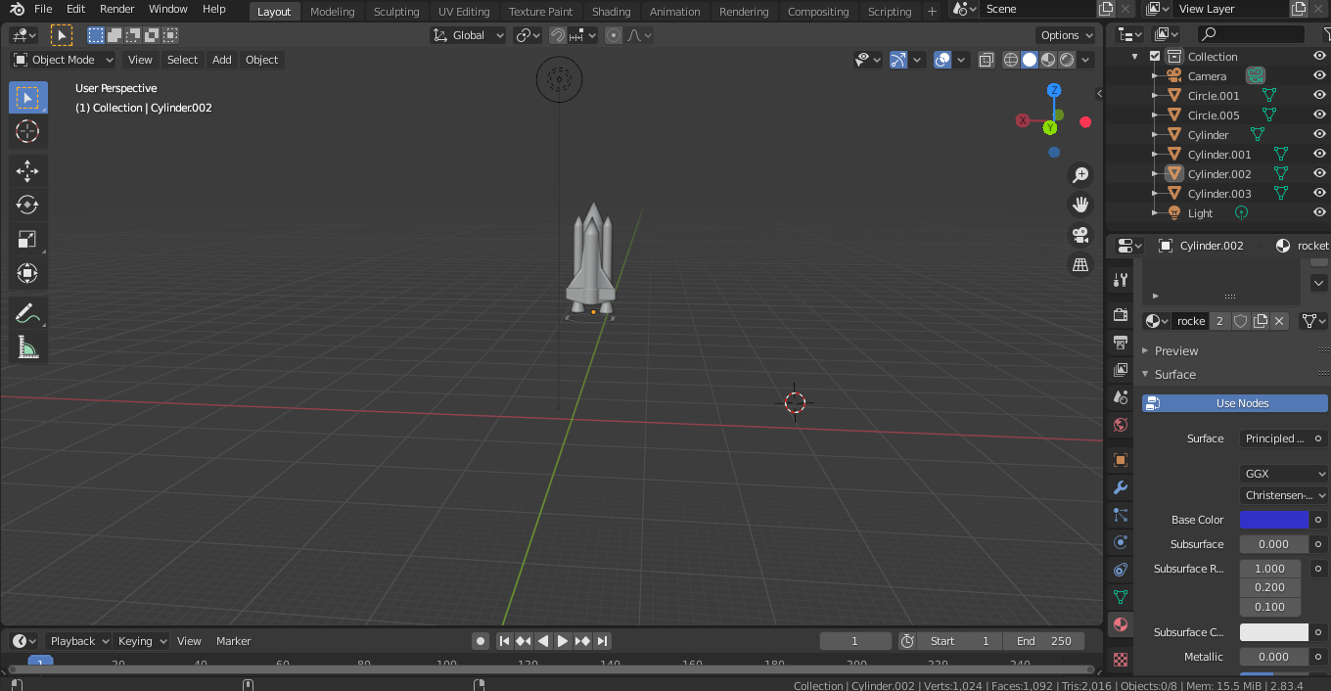

**Link:** [GAT Lab - Experiment 7 (All Files)](https://drive.google.com/drive/folders/1G6oqKeyo6eZ-F9WN3lkJp1JIyfxqso51?usp=sharing)

**Conclusion:** Hence, we have designed an attractive 3D model of a rocket.